Waterways Management
Show your support
By sharing the following social media tiles far and wide

Suggested post text | Accompanying asset
As a ratepayer in Strathbogie Shire, I’m supporting their calls to the Victorian Government to fully fund the waterway management role.  The service is costing ratepayers about $200,000 each year to deliver a service that’s not a Local Government responsibility.  It’s essential this life saving service continues, but it needs to be funded by the responsible authority.  Please help us by sharing this post!  #fundourwaterways #keeplakenagambiesafe | 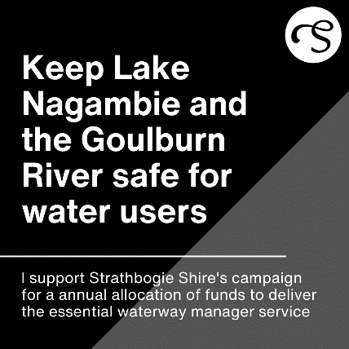
As a business owner in Nagambie in the Strathbogie Shire I know how important Lake Nagambie and the Goulburn River waterways are to our success.  It’s a key driver to our economic prosperity and draws thousands of visitors to our region each year.  However, it’s not fair it’s costing Council – and in turn us as ratepayers – about $200,000 to deliver each year.  All we’re asking for is for the responsible authority (the Victorian Government) to fully fund the program it’s responsible for.  Surely that’s not too much to ask?  Please help us by sharing this post!  #fundourwaterways #keeplakenagambiesafe #keepourregionprosperous | 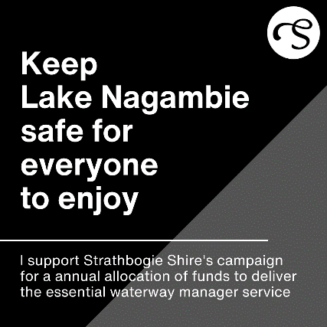
We’re regular visitors to the Nagambie region and we love spending time on the water.  But we’re concerned to learn the role of waterways manager is being delivered by Strathbogie Shire Council at a cost of about $200,000 a year, with no financial support from the responsible authority.  This role is essential to visitors and waterway users.  We’re joining the calls for the responsible authority (the Victorian Government) to fully fund the program it’s responsible for.  Please help us by sharing this post!  #fundourwaterways #keeplakenagambiesafe #keepourregionprosperous | 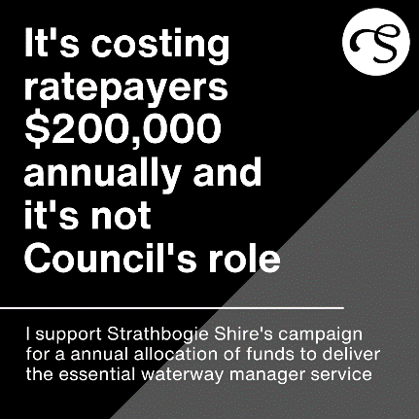
As a ratepayer in Strathbogie Shire, I’m supporting their calls to the Victorian Government to fully fund the waterway management role.  The service is costing ratepayers about $200,000 each year to deliver a service that’s not a Local Government responsibility.  It’s essential this life saving service continues, but it needs to be funded by the responsible authority.  Please help us by sharing this post!  #fundourwaterways #keeplakenagambiesafe | 