Greening Euroa Project
Show your support

We know the Greening Euroa Project is a no brainer!

Community driven. Victorian first. Sustainable. Awesome!

But, we want to ensure every hears our story and that we secure the $3.8 million needed to see the project become a reality.

You can help us by showing your support, helping spread the word and creating a buzz about the Greening Euroa Project.

Use the below social media posts below to share this fantastic project far and wide so we can encourage our State and Federal leaders and other philanthropic bodies to provide funding to install the required infrastructure.

And remember…..#LetsGreenEuroa!

Suggested post text | Accompanying asset
We support the Greening Euroa Project because we want to see local kids playing on green ovals.  The Greening Euroa Project will create green ovals and play areas for our children – year-round and even during drought!  It’s about learning; it’s about our children so #LetsGreenEuroa!  > Learn more by watching this informative video.  > Read about the project here. | 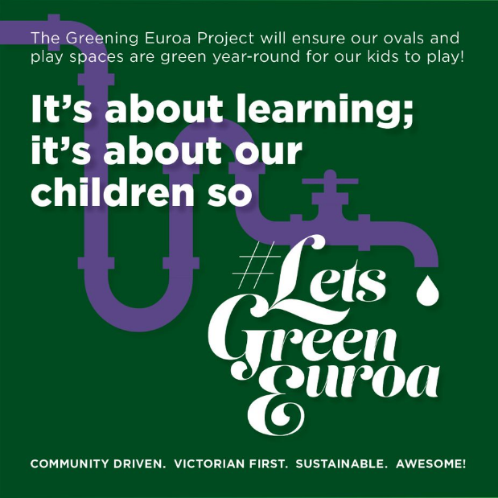
We support the Greening Euroa Project so our sporting fields and ovals can flourish for current and future generations to enjoy!  Community sport is at the heart of Euroa and playing on green grounds ensures the overall wellbeing of our players.  The Greening Euroa Project is securing the future of community sport.  > Learn more by watching this informative video  > Read about the project here  #LetsGreenEuroa! | 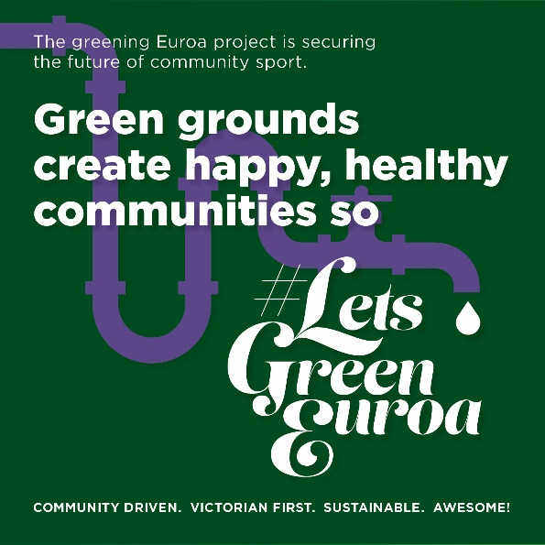
I support the Greening Euroa Project because it will lessen the impacts of chronic water shortages in a rapidly warming climate.  The project uses recycled water to irrigate our public green spaces.  It’s a win for everyone. Community, children and the environment.  > Learn more by watching this informative video  > Read about the project here  #LetsGreenEuroa! | 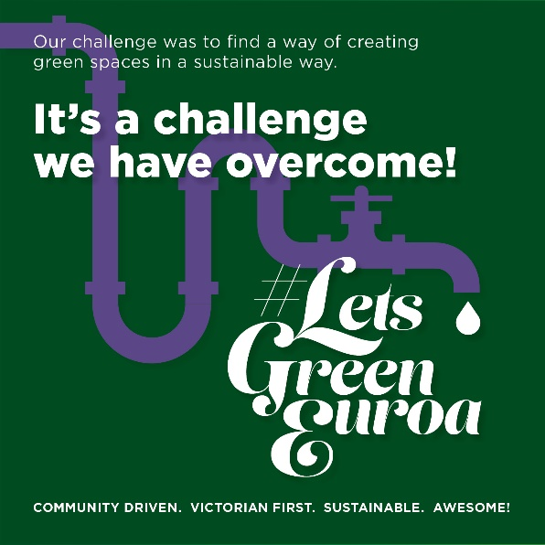
I support the Greening Euroa Project because it’s climate smart, cost efficient and community inspired.  It demonstrates smart use of our valuable water resource and takes pressure off our potable water supply.  It’s simple, it’s sustainable and it will take the pressure off our town water supply.  > Learn more by watching this informative video  > Read about the project here  #LetsGreenEuroa! | 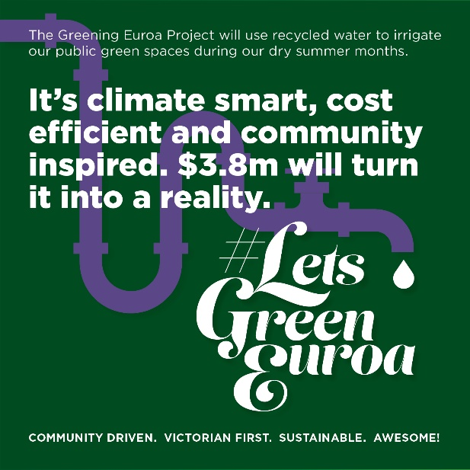
I support the Greening Euroa Project because my town is important to me.  I want to see our green spaces green during the summer months – it’s essential to our health and wellbeing.  Whether you play sport, go to school, or just love Euroa - this is an important project to get behind and show your support.  > Learn more by watching this informative video  > Read about the project here  #LetsGreenEuroa! | 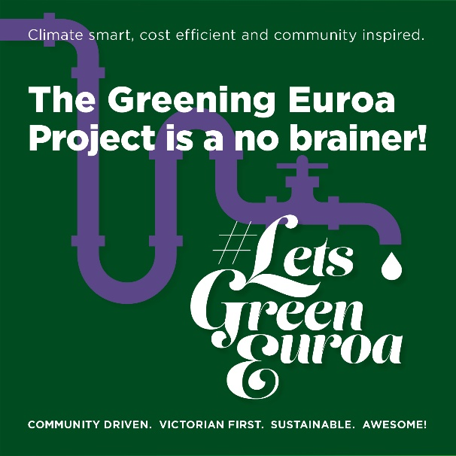

For further information:

Tara Whitsed
E: tara.whitsed@strathbogie.vic.gov.au
P: 0447 712 121

