Strathbogie Shire Council
2018-2019
Community Grants Program Guidelines

For projects commencing after July 1, 2018
Opens: Monday March 19, 2018
Closes: Friday April 20, 2018

Online applications can be lodged at

www.strathbogie.vic.gov.au/community/community-funding/community-grants-program

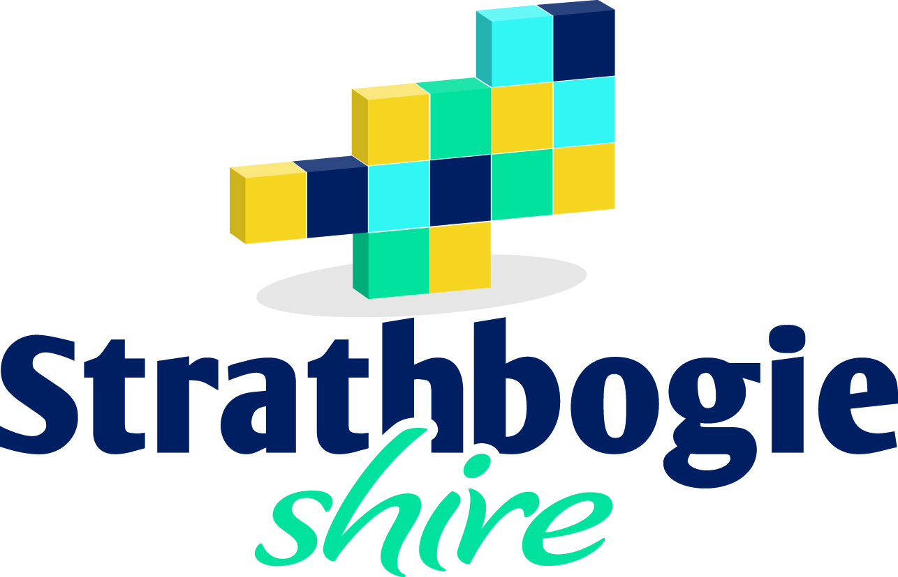

Address:
109A Binney St, Euroa
PO Box 177, Euroa 3666
www.strathbogie.vic.gov.au info@strathbogie.vic.gov.au

Contents
IMPORTANT THINGS YOU NEED TO KNOW BEFORE YOU START 3
COMMUNITY GRANTS PROGRAM TIMELINE 2018-2019* 4
PRINCIPLES OF THE COMMUNITY GRANTS PROGRAM 4
GENERAL GUIDELINES – For all categories 5
1. Who is eligible to apply? 5
2. Features of an eligible application 5
3. Who is not eligible to apply? 5
4. What is not eligible for funding? 6
5. Community Grants and GST 6
6. Grant conditions 6
HOW TO APPLY 7
SPECIFIC GRANT CATEGORY GUIDELINES 7
ACTIVE & HEALTHY COMMUNITIES 8
ARTS, CULTURE & EVENTS 9
ENVIRONMENTAL & SUSTAINABILITY 10
FACILITIES & INFRASTRUCTURE 11
SMALL PROJECTS GRANTS 12

If you are unsure about any information outlined in these Guidelines or would like to discuss your application further, please contact a member of the Community Wellbeing Team on 5795 0000 or by emailing info@strathbogie.vic.gov.au

IMPORTANT THINGS YOU NEED TO KNOW BEFORE YOU START
- Read the Guidelines carefully. It is important to have a full understanding of the Guidelines before you start completing the online application.
- The term project is used throughout this document. Project means any activity, event, initiative or program that you are seeking funds for.
- It is a condition of application that you discuss your proposed project with a member of the Community Wellbeing Team. This will help to:
  - Check your group is eligible for funding.
  - Check your project is eligible to be funded and that you are applying in the correct category.
  - Clarify any queries you may have about the guidelines and online application process.
- Please note if you apply under an incorrect category we are unable to move your application to a more appropriate category and your chance of receiving funding will be reduced.
- Final decision regarding grant application is determined at the at the June Council meeting.
- The amount of funds awarded will be dependent on number and quality of applications. Please note: you may not receive the full amount of funds you have applied for.
- The maximum grant amount for each category is as follows:
Grant Category | Amount
Active and Healthy Communities | $5000
Arts, Culture and Events | $5000
Environment and Sustainability | $5000
Facilities and Infrastructure | $5000
Small Projects | $1000
- Applicants are required to contribute towards the implementation of their project; this may include cash or in kind contributions or a combination of both. There is not minimum contribution required however evidence of the contribution must be provided.
- Please ensure your group has current public liability insurance to an amount of $20,000,000 for your project. You will be required to include an attachment of this with your application. Failure to do so may render your application ineligible.
- Applications can only be received from incorporated groups. If your group is not incorporated, you will need to seek out an incorporated group or a Community Planning Reference Group (also known as Community Action Group) who is willing to auspice (endorse) your application.
- If your group is submitting an application for funding you may also agree to act as auspicing group for another non-incorporated group.
- If your group has received Community Grants Funding previously you will need to complete any outstanding project acquittal requirements before being eligible to reapply for the current round of the Community Grants Program. The Grant Acquittal Form is available on your SmartyGrants account that you used to apply for your previous Grant.
- Any questions regarding acquittal requirements can be directed to the Community Wellbeing Team on 5795 0000.

COMMUNITY GRANTS PROGRAM TIMELINE 2018-2019*
Applications Open | Monday March 19, 2018
Applications Close | Friday April 20, 2018
Applications assessed | May 2018
Recommendations to Council for decision | Tuesday June 19, 2018
Applicants advised of outcome | Friday June 22, 2018
Project can commence from | July 1, 2018
Project Completed and Acquittal Submitted | Friday May 31, 2019
*Excluding Small Projects Grants

PRINCIPLES OF THE COMMUNITY GRANTS PROGRAM
The Community Grants Program provides an opportunity for groups to undertake projects that complement the focus areas identified as priorities for the Strathbogie Shire Council.

Applications are sought for projects that:

- Promote community engagement and participation.
- Support gender equality and social inclusion and improve accessibility.
- Contribute to building healthy and vibrant communities.

It is recommended that your project should directly relate to a strategic goal that is specified in one or more of the following documents:
- Strathbogie Shire Council Plan 2017-2021 - click HERE
- Strathbogie Shire Council Liveability Plan 2017-2021 - click HERE
- A Community Plan developed by the Community Planning Reference Group in your community - click HERE

GENERAL GUIDELINES – For all categories

1. Who is eligible to apply?
To be eligible for funding under the Community Grants Program, applicants must be:
- A not for profit community group, organisation or club that is incorporated.
OR
- An unincorporated not for profit community group, organisation or club that has an auspicing body that is an incorporated not for profit community group, organisation or club OR a Community Planning Reference Group (also known as Community Action Group).

2. Features of an eligible application
- The project must be based in the Strathbogie Shire municipality.
- The project will generate positive outcomes for Strathbogie Shire residents and/or visitors.
- The applicant is able to demonstrate their own contribution to the project in the form of funds or in kind support.
- There is demonstrated support for the project from other groups within the community (such as formal partnerships, letters of support and / or a financial commitment to the project).
- The applicant is able to demonstrate sound project planning.
- The project considers gender equity, inclusion, accessibility and cultural diversity.

3. Who is not eligible to apply?
- An individual.
- An unincorporated not for profit community group, organisation or club without an appropriate auspicing body.
- Any group who has an overdue acquittal of a previous Community Grant.
- Any group already receiving other financial support from Council or where their funding and service agreement precludes access to other Council funding.
- Private, profit making organisations.
- Emergency services, Educational Institutions and Religious organisations.

4. What is not eligible for funding?
- Applications for retrospective funding, including for projects that are due to start before 1 July 2018.
- Applications seeking funds to cover the cost of fundraising, prizes and/or wages.
- Applications seeking sponsorship to attend conferences or sporting events.
- Projects that are to occur primarily outside of Council ’s municipal boundary.
- Applications from federal or state government agencies and private profit making organisations or individuals.
- Applications that are incomplete such as: not attaching evidence of public liability insurance coverage and not attaching copies of relevant quotes.

Community Grants and GST
- Where the applicant is registered for GST Council will pay the grant amount requested plus 10%. The Applicant will then remit to the Australian Tax Office (ATO).
- If the applicant is not registered for GST, or is not auspiced by a group registered for GST, 10% will be added to GST items as part of the total grant sum.
- Grant maximum amounts to remain as suggested, noting that the amount will cover GST, with any amount over that to be funded by the applicant.

Grant conditions
Successful applicants will be required to:
- Enter into a funding agreement and adhere to the conditions of the agreement.
- Spend the grant money only as stated in the original application. Approval for any proposed variation to the project must be sought in writing via the Manager Community Wellbeing, and permission received in writing, prior to a new project or variation commencing.
- Return any unspent funds at the completion of the project or the end of the agreement unless prior approval has been obtained to expend the funds.
- Complete a project plan and obtain all necessary permits, compliance requirements as deemed necessary for your application.
- Obtain all necessary approvals (E.g. Letter from land owner) and permits (building/planning or other statutory requirements) associated with your project; failure to do so will result in the project being delayed, or potentially, stopped.
- Inform Council officers of changes to key project contact details, including telephone number, email or postal address.
- Invite Council officers and Ward Councillor/s to the project launch if applicable.
- Acknowledge Council in all public and promotional materials.

HOW TO APPLY

- All applications are completed online at: www.strathbogie.vic.gov.au/community/community-funding/community-grants-program
- Please answer all questions and attach all information as requested. Failure to do so may render your application ineligible.
- Applicants may only submit one application for Community Grants per year.
  - Late applications will not be considered, and no extensions will be granted.
  - A successful funding application in any round does not imply ongoing funding.

SPECIFIC GRANT CATEGORY GUIDELINES
The Community Grants Program is divided into five categories, each of which has specific guidelines. Please make sure you refer to the specific guidelines for the relevant category before you start.
Sometimes the project may appear to be applicable to more than one category – if this is the case, please call the Community Wellbeing Team to discuss your proposal and receive advice about which is the best category to submit your proposal.
Once the application has been submitted it is not possible to change it to a more appropriate category and your chance of success may be reduced.

Note: depending on the specific project, additional information may be required before final approval is given. If applicable, this information will be sought when a project has been short listed.

ACTIVE & HEALTHY COMMUNITIES
(To be read in conjunction with the general guidelines)

The Active and Health Communities category supports:
- Local projects that promote collaboration and resource sharing among groups.
- The development of new or expanding existing programs and activities for example craft workshops, walking groups, community engagement programs or formal and informal sport and leisure activities.
- The purchase of project related equipment/materials e.g.: purchase of printer, materials for workshops and/or project costs such as printing, facility hire, consumables
- Building more capable community groups for example committee of management training, leadership/skill development and/or Volunteer development and/or skills training initiatives that will increase the efficiency of volunteer roles and responsibilities.
- Provision of essential equipment with priority given to safety equipment e.g. defibrillator, safety padding.

The project should be free or low cost for the community to attend.
Applicants must keep a record/register of volunteer involvement and audience attendance at all activities associated with the project and submit with the project acquittal report.

Eligibility
Successful applications/applicants will be required to:
- Demonstrate how the project contributes to developing the health and wellbeing of residents of the Strathbogie Shire.
- Demonstrate the Community benefits of the project for example how will the project strengthen and develop community skills, promote awareness and/or action with regards to community issues and provide opportunities to increase skills /knowledge of community members
- Demonstrate how the project is accessible and inclusive of all members of the community and if it addresses gender equality.
- Demonstrate sound Project Planning and Risk Management skills.

Successful funding in this round does not imply ongoing funding.
Groups should always work towards a sustainable funding model for projects that are intended to be ongoing.

ARTS, CULTURE & EVENTS
(To be read in conjunction with the General Guidelines)

The Arts, Culture and Events Grant category supports:
- Arts and Culture based initiatives that engage the broader community in creative activities i.e. performance seasons, workshops, residencies, master classes, tours, exhibitions.
- Local artists and organisations to develop art projects that increase the community participation in the arts.
- Local events that celebrate diversity and reduce isolation of individuals and groups and are accessible to and inclusive of all members of the community.
- Local events that promote awareness of community issues and strengthen and develop community skills i.e. leadership, performance skills, event management.
- Events that maximise the economic benefits to our community from scheduled festivals, cultural events business events, major events and sporting activities.
- Events that celebrate the tourism product strengths in the region to encourage a diverse range of events to increase visitation to the region.
- Opportunities that assist to sustainably build the region’s tourism products.

The project should be free or low cost for the community to attend.
Applicants must keep a record/register of volunteer involvement and audience attendance at all activities associated with the project and submit with the project acquittal report.

Specific information for Events:
Grants approval does not constitute Event approval.
Events will be eligible for Grants funding for a maximum of 3 years.
You will still need to ensure your event meets all Event Management Guidelines. Event management plans that include a risk assessment, emergency procedures and weather contingencies (for outdoor events) form part of any well managed event.

Eligibility
Successful applications/applicants will be required to:
- Demonstrate how the project contributes to developing the cultural vibrancy of the Strathbogie Shire area and supports local creativity and innovation.
- Demonstrate the Community benefits of the project for example how will the project strengthen and develop community skills such as leadership, performance skills, event management.
- Demonstrate how the project is accessible and inclusive of all members of the community and if it addresses gender equality.
- Demonstrate sound Project Planning and Risk Management skills.

Successful funding in this round does not imply ongoing funding.
Groups should always work towards a sustainable funding model for projects that are intended to be ongoing.

ENVIRONMENTAL & SUSTAINABILITY
(To be read in conjunction with the general guidelines)

The Environmental and Sustainability category supports:
- Community groups to undertake a range of environmental sustainability projects which improve our natural and built environments for example community garden projects or the provision of essential group equipment
- Environmental projects for waste and resource management, and recycling initiatives.
- Sustainability Projects to improve energy efficiency or implement sustainable transport initiatives.
- Conservation and climate change projects such as landscape restoration and re-vegetation projects or Pest plant and animal control projects
- The development of Environmental and Sustainability educational programs, behaviour change project, field days or workshops, developing brochures, booklets and other resource materials.

The project should be free or low cost for the community to attend.
Applicants must keep a record/register of volunteer involvement and audience attendance at all activities associated with the project and submit with the project acquittal report.

Eligibility
Successful applications/applicants will be required to:
- Demonstrate how the project contributes to environmental sustainability outcomes and benefits.
- Demonstrate the Community benefits of the project for example how will the project strengthen and develop community skills such as leadership, performance skills, event management.
- Demonstrate how the project is accessible and inclusive of all members of the community and if it addresses gender equality.
- Demonstrate sound Project Planning and Risk Management skills.

Successful funding in this round does not imply ongoing funding.
Groups should always work towards a sustainable funding model for projects that are intended to be ongoing.

FACILITIES & INFRASTRUCTURE
(To be read in conjunction with the general guidelines)

The Facilities and Infrastructure category supports:
- Minor capital purchases such as furniture and equipment.
- Improvements to community facilities such as minor capital work projects or make non-essential modifications to community facilities, for the benefit of facility users.
- Small infrastructure projects such as costs towards an all abilities ramp.
- Children’s playgrounds or recreational space improvements.

The project should be free or low cost for the community to attend.
Applicants must keep a record/register of volunteer involvement and audience attendance at all activities associated with the project and submit with the project acquittal report.

Eligibility
Successful applications/applicants will be required to:
- Demonstrate how the project contributes to improving and developing facilities and infrastructure in Strathbogie Shire.
- Demonstrate the Community benefits of the project for example how will the project impact on user groups of the facility.
- Demonstrate how the project is accessible and inclusive of all members of the community and if it addresses gender equality.
- Demonstrate sound Project Planning and Risk Management skills.
- Provide evidence of approval from the building owner for any works to be undertaken.

Successful funding in this round does not imply ongoing funding.
Groups should always work towards a sustainable funding model for projects that are intended to be ongoing.

SMALL PROJECTS GRANTS

Small Projects Grants are available for applicants that have missed the submission dates for Community Grants from other categories.

Groups are only eligible to receive this grant once per year and are not eligible for a Small Project Grant if they are currently expending other Strathbogie Shire Community Grant Funds.

Small Project Grants must meet the criteria for one of the four Community Grant Categories:
- Active and Healthy Communities
- Arts, Culture and Events
- Environmental and Sustainability
- Facilities and Infrastructure

Small Projects Grants must be acquitted within six months of the submission of their Terms and Conditions unless otherwise negotiated with the Manager Community Wellbeing.

Application process
Applications are accepted all year (or until funding allocation is exhausted) from 1 July 2018.
Small Project Grants are assessed on a monthly basis.

Eligibility
As per Community Grants Category under which the applicant is applying.

