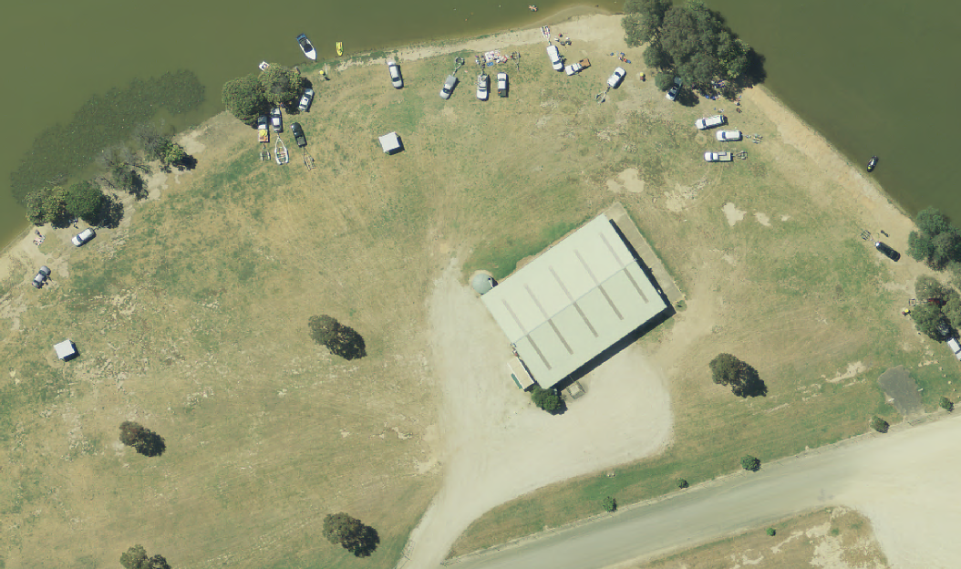
 | Shire Of Strathbogie | Disclaimer Note  This map is a representation of the information currently held by Strathbogie Shire Council. While every effort has been made to ensure the accuracy of the data, Council disclaims all liability for any loss, cost, damage or injury, howsoever arising or connected with the use of this data. Any feedback on omissions or errors would be appreciated.  Contains Council Information © Strathbogie Shire Council  Contains Vicmap Information © Department of Environment, Land, Water & Planning |  | 18/02/2015
 | Prepared By: Claire Hahnel |  |  | 1:699

