Native Vegetation Removal Request
Once this form is completed it is to be forwarded to the Sustainable Development department who will review and provide a response within 10 working days. Please ensure that all relevant documentation is supplied, otherwise this process may be delayed.
Contact Name / Organisation
Contact email
Contact Phone
Address of site
Proposed date for works
Person/Company undertaking works
Date Submitted
Is the Vegetation Native? | ☐Yes  ☐No  ☐Unsure
Full description of Works Required
Have any vegetation removal works previously been undertaken on this site? | ☐No  ☐Yes DATE:  Description of works completed :
Are all works being conducted on your land?

If not, have you gained appropriate consent from the land owner/roadside manager?
If conducting native vegetation removals on Crown Land state the insurances of those undertaking the works.  This document is deemed to be a valid declaration of insurance policies held. | ☐Professional Indemnity Insurance (contractors & company’s)  ☐Your farm liability insurance (individuals)  ☐No insurance  Council reserves the right to deny works occurring on land it manages if it deems the risks to life and property to be too extreme.
Has a Council Officer visited the site? If yes, provide names and date of site visit.
Is there any threatened flora or fauna within the vicinity of the works? (Check with the Shire) | ☐Yes  ☐No  ☐Unsure
What is proposed to occur to disturbed and removed native vegetation? | ☐To remain in vicinity of removal  ☐Remove for personal use  ☐Remove for other reasons (please state below)
Insert a Locality Map here of worksite (incl. Adjacent Rd names) with trees marked and include Photo number as listed in Vegetation to be Removed table below:

Vegetation to be Removed (additional lines can be inserted if necessary) SEE EXAMPLE BELOW
Image | Common Name | Diameter of trunk  (if tree) / M² ground cover | # branches affected
1
2

Insert numbered images matching the above matrix of all affected native vegetation below
OR attach numbered image files to your email along with this form.

IMAGE #1

IMAGE #2

IMAGE #3

IMAGE #4

IMAGE #5

EXAMPLE ONLY : ATTACHMENT A

Insert a Locality Map here of worksite (incl. Adjacent Rd names) with trees marked and include Photo number as listed in Vegetation to be Removed table below:
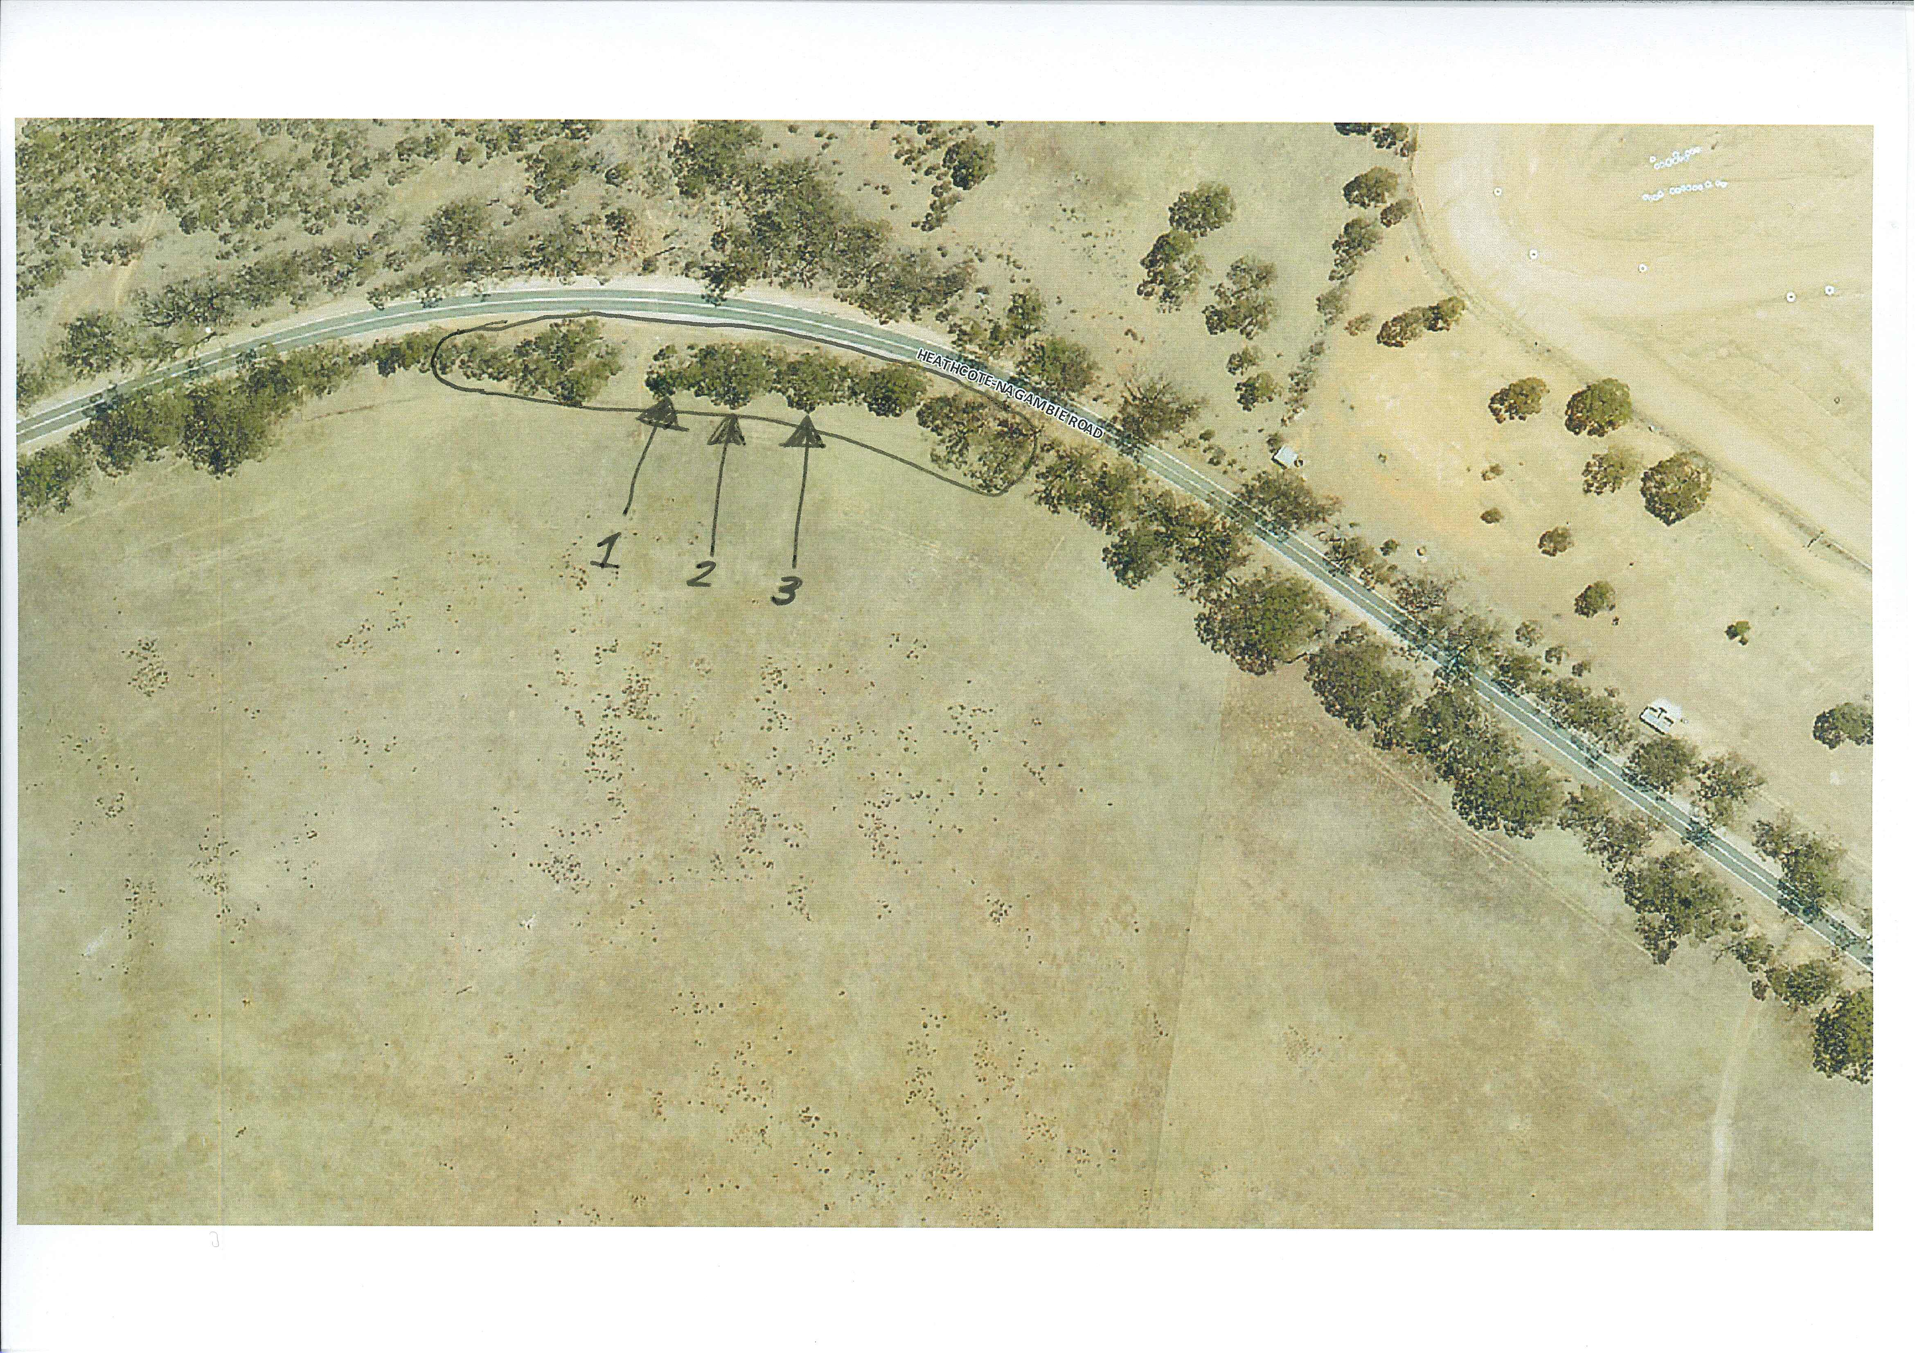

Image | Common Name | Diameter of trunk  (if tree) / M² ground cover | # branches affected
1 | Grey Box | 20cm | Whole tree
2 | Black Wattle | 10cm | 2 branches
3 | Wallaby Grass | 2m²

Insert numbered images matching the above matrix of all affected native vegetation below
OR attach numbered image files to your email along with this form.

IMAGE #1
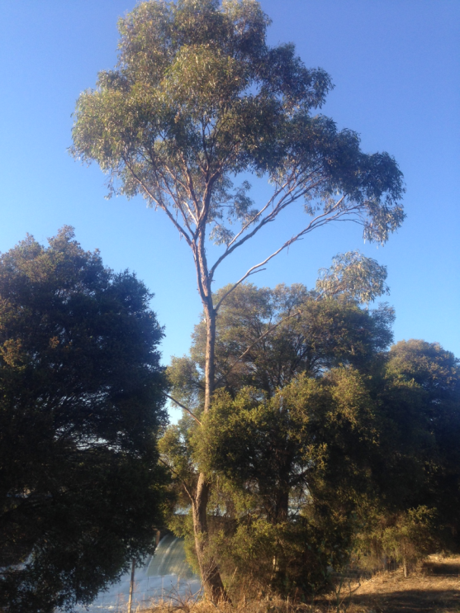

IMAGE #2
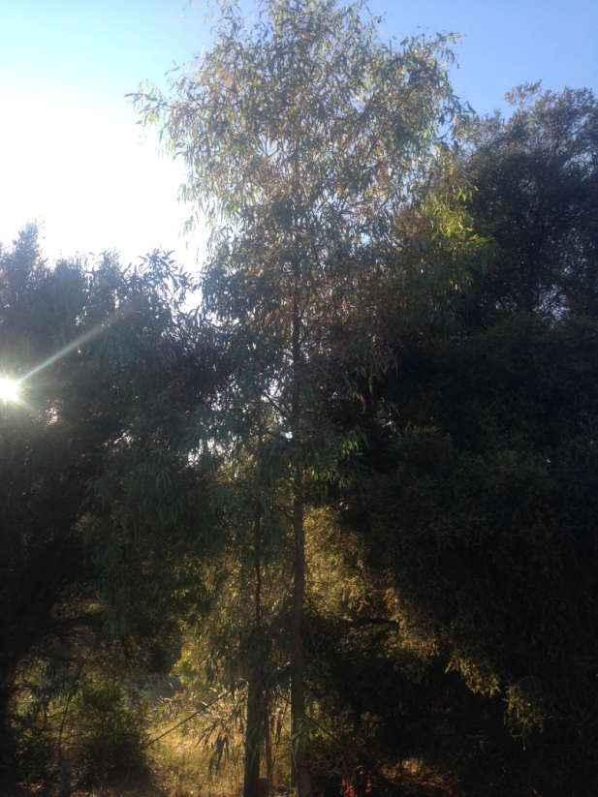

IMAGE #3
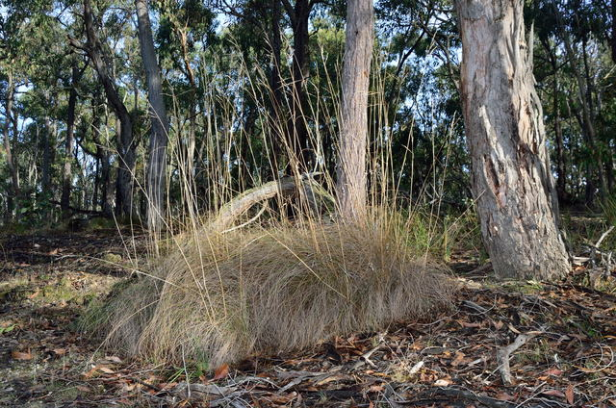

IMAGE #4

IMAGE #5

