Introduction

This social story is designed for visitors to Euroa Community Cinema who may have autism, sensory and learning challenges and anxiety.

We welcome all guests to the Euroa Community Cinema. The atmosphere is non-judgmental and ‘relaxed’. Guests can choose their own seats and move around as they need.

We invite you to ‘be yourself’ and enjoy the screening.

This document contains information about coming to Euroa Community Cinema, images of what to expect when you arrive and information about the films. It is intended for parents, carers and teachers to share with children in whatever way is most helpful.

Please advise us if we can provide anything further.

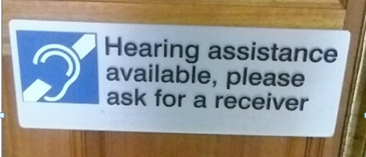

We always welcome feedback on our work so please don’t hesitate to suggest areas where we can improve.

Part 1

Soon we will be going to see a screening in the cinema.

This is the first thing you will see when you come to Euroa Community Cinema
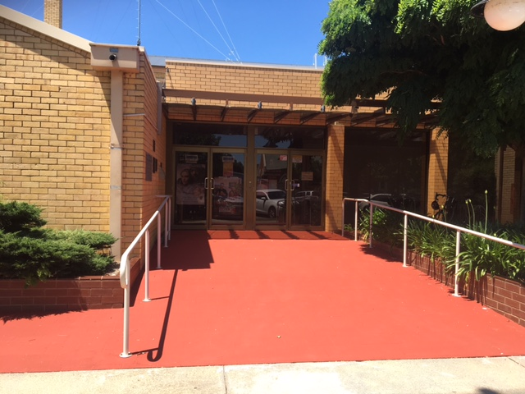

Some of the people will be working at the cinema helping the guests.

At Euroa Cinema you will come to the entrance

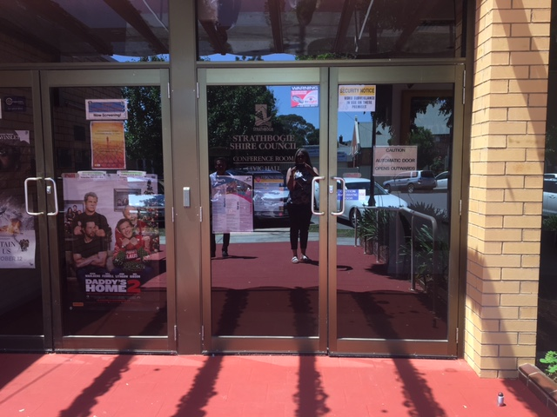

There is door that will open towards you

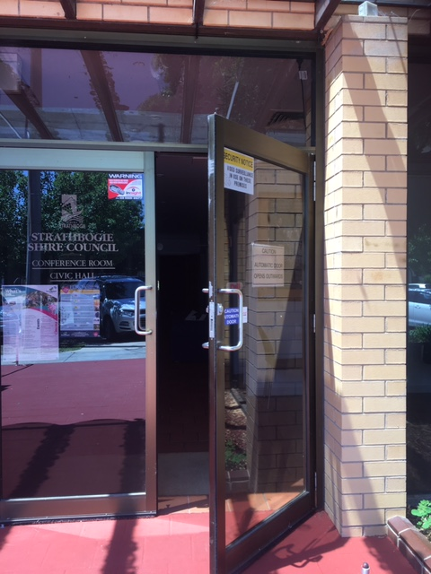

The door is automatic and will open as you get close to it

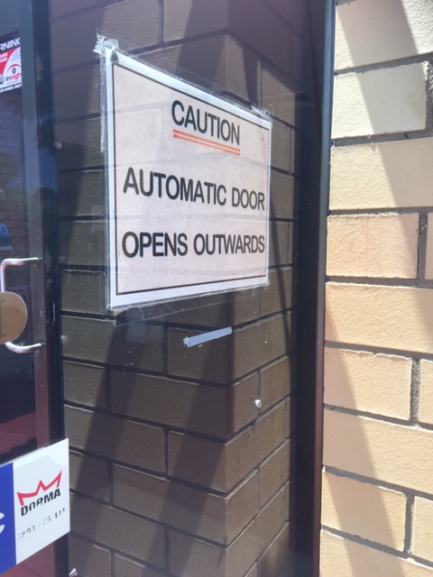

You may need to take a step backwards when the door opens

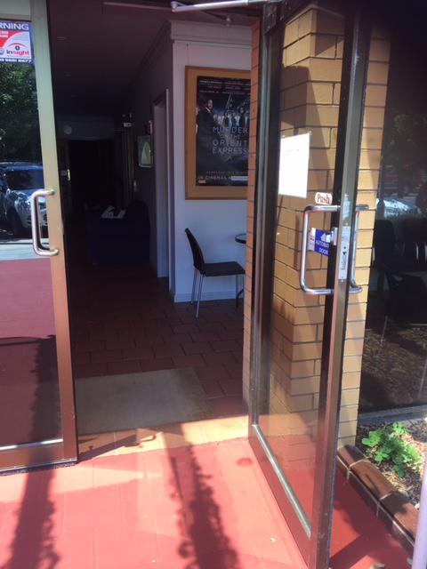

When you come inside you will walk towards the wooden doors to get to our screening room

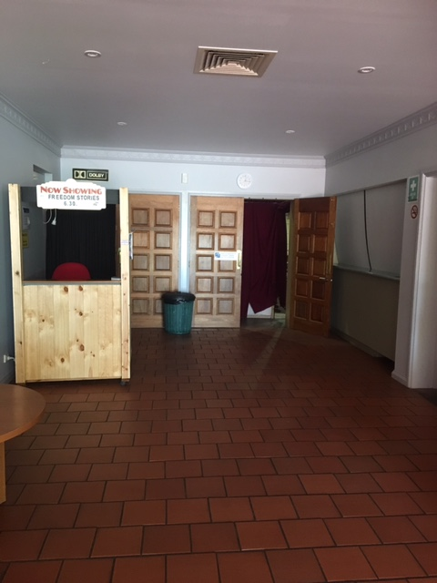

Let’s Go Inside

The screening room has some red seats.

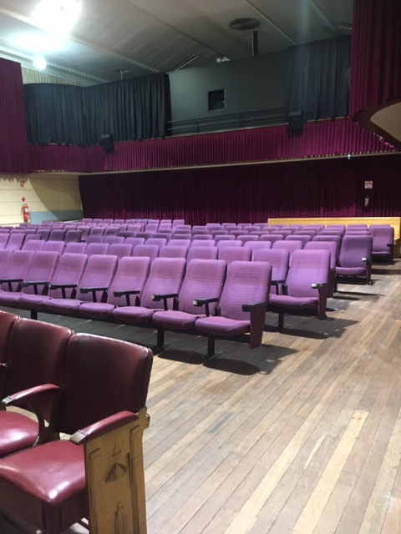

There are lots of chairs and you can choose one to sit in.

At the front of the screening room is a big white screen. This is where you will see the film. It is important not to touch the screen because that spoils the way the film looks.

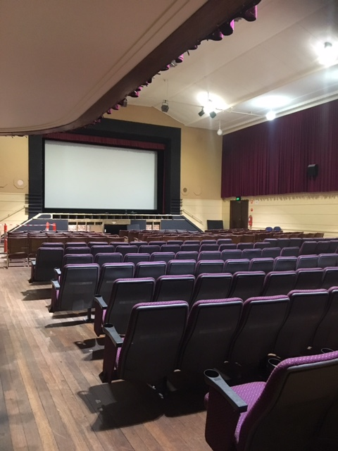

If you need a break there will be a chill out area where you can go to relax. You turn left when you go out of the screening room.

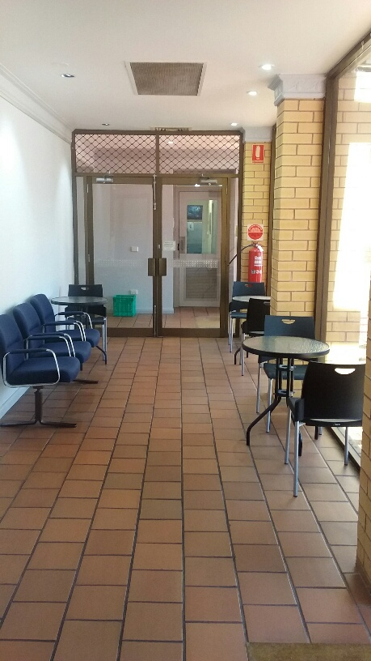

Or just outside the screening room, there are some blue couches.

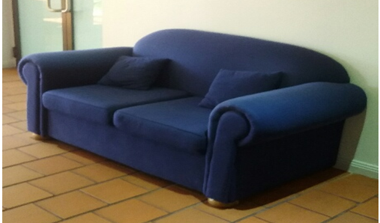

Going to the Toilet

The toilets are outside the screening room. You will see the doors to the toilets on the left when you go out of the screening room.
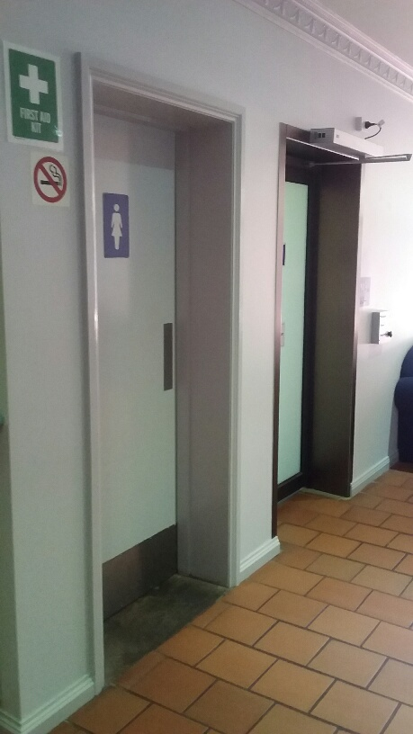

Inside the Girls toilets
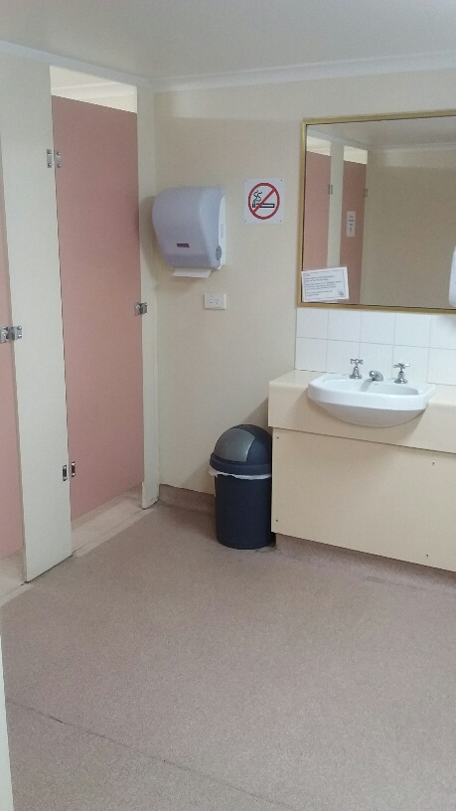

The boys toilets

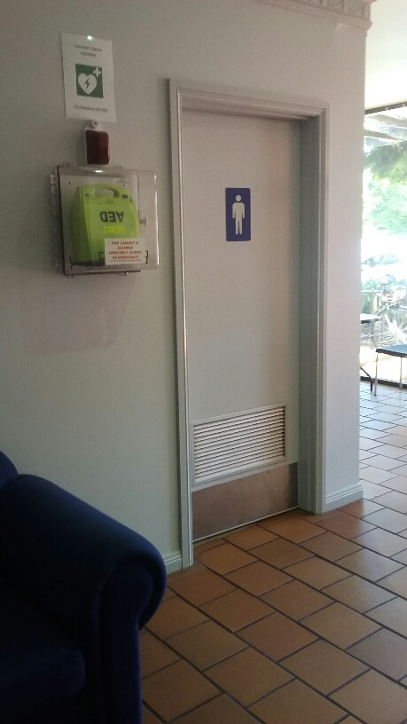

Inside the boys toilets

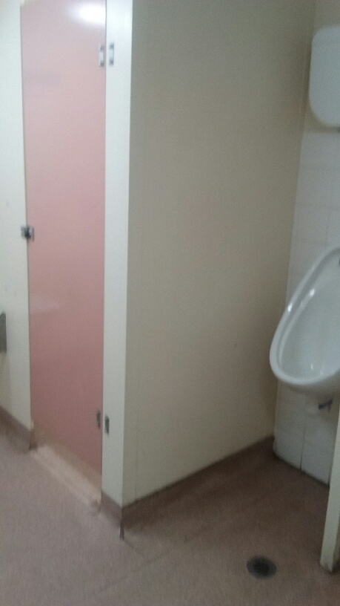

There is an accessible toilet. You push the green button to open the door.

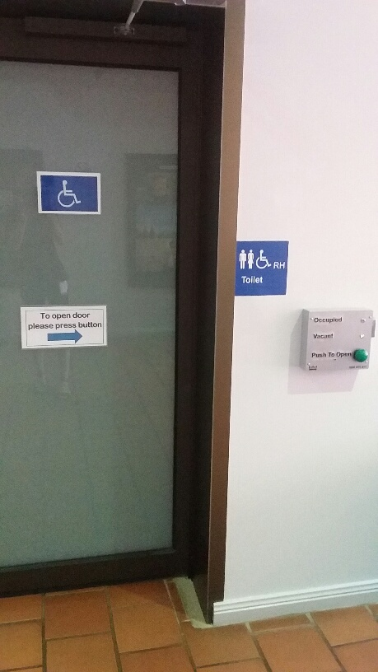

Inside the accessible toilet
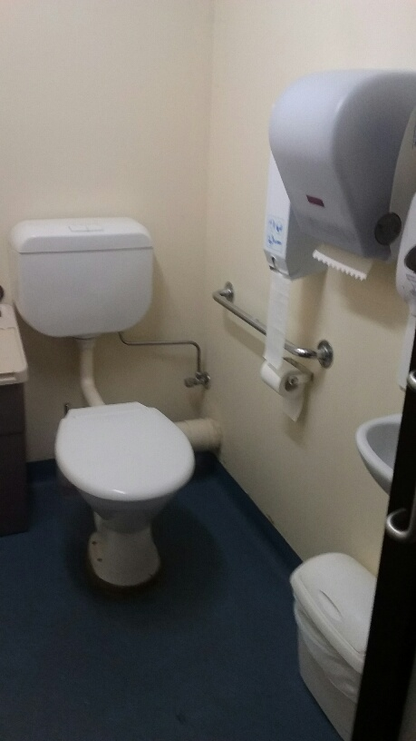

At the end of the screening

When the screening is over wait for the adult with you to tell you when your group is leaving the cinema. You will go back out of the cinema the same way you came in.

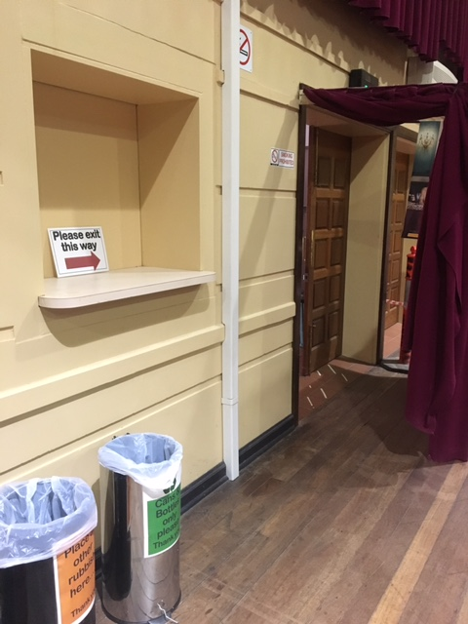

Part 2

The Screening

When you sit in your chair you will need to wait for a little while. It’s alright to speak to someone sitting next to you while you are waiting if you want to.

There will also be music playing before the movie starts.

After a short time, the lights will dim and this is when the movie is about to start. There will be a number of ‘trailers’ about other movies that will be playing at the cinema another time.

Then the movie that you are coming to see will start.

After the movie is finished, the lights will come back on and you can exit the same way that you entered the Euroa Community Cinema.

