How to lodge a Statement of Trade (SOT)
Please note: unless you submit your Statement of Trade at the same time as you apply for your registration, you will not be able to lodge a Statement of Trade until your registering council has accepted your application.
Go to Streatrader and use the Login button (circled in red) to access your account.
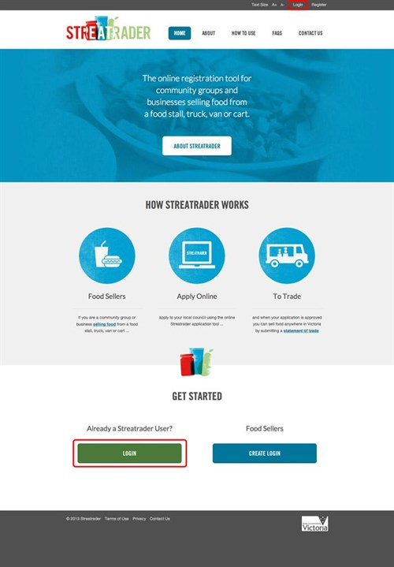
Enter your ‘Email’ and ‘Password’ and select the button
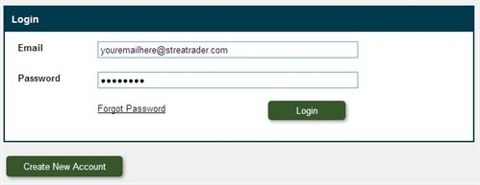
Once you have logged into Streatrader, from the menu on the left side of the screen select “Lodge a Statement of Trade” and a Statement of trade application will open.
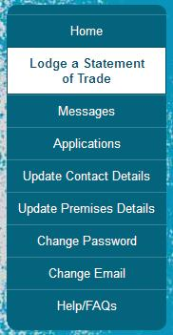
Select the green button at the bottom of the screen. This will allow you to complete the SOT application.
You will then be asked to select which premises you wish to add the SOT to. Most users will only have one premises.
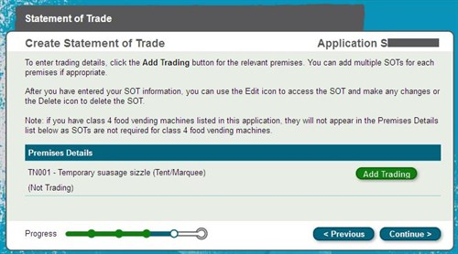
Press the button next to the relevant premises that you would like to submit a SOT for.
The trading details screen contains a list of pre-defined Events. This list can be searched by Event Name, Suburb or Council. Select the Event from the list and select continue.
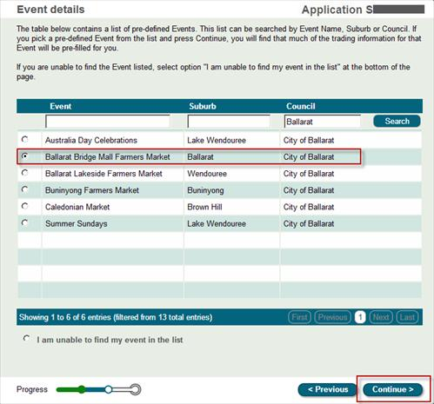
If you are unable to find the Event listed, select option "I am unable to find my event in the list" at the bottom of the page and select continue.
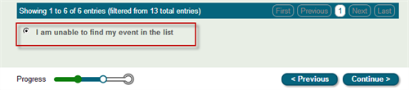
If you selected an event from the list confirm the dates you are trading, you are able to reset the dates or delete dates by selecting the cross. Once you have finalised the dates select continue.
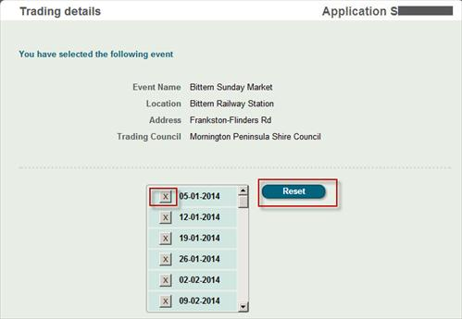
If your event was not on the list you will need to enter the details of where and when you plan to sell food. You will be required to enter:
- Location description eg: name of park, outside a shop or store
- Event name eg: festival, market name
- Street address
- Suburb or Town by selecting the “select suburb” button.
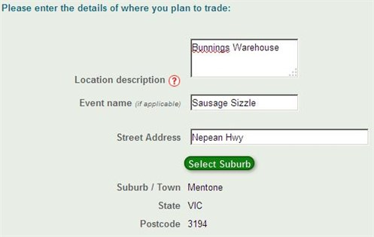
You can then add in the dates you plan on trading by selecting the dates on the calendar below the location details. To change months, from the drop down listing select the correct month. To add a date to the Statement of trade, select the date on the calendar, and the date will be added to the list on the right.
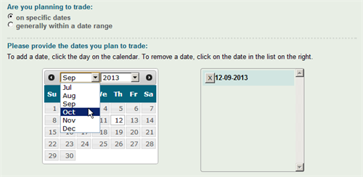
If you trade at the same location on multiple days, you can click on the multiple dates on the calendar and add multiple dates to one SOT.
When you have added all the dates of trading, select the button at the bottom of the screen.
You will be shown a review of the details you have entered in to the SOT as shown below.
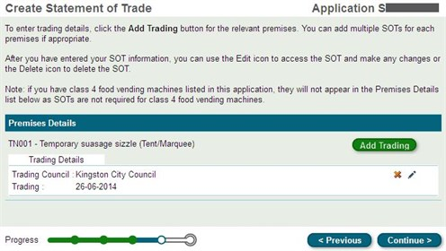
You can then add more SOTs by pressing the button. If you need to amend any details, select the Edit button next to the SOT you would like to amend.
If the details are correct, select the button. You will then be taken to the validation screen.
If the Message shown says Valid, you can select the button to complete the declaration page.
Complete the declaration and select
You are now ready to send the SOT to Council. Once you select the button your application will be sent to Council and you will be returned to your home screen where you can continue to use Streatrader or logout of the system.

